**Jira bug Template**

**[Bug:01]**

**Bug Summary:**

[Laptop-Chrome] [Patient Portal] [Sign Up Page] Placeholder titleis still showing after selecting the drop down option for Gender

**Description:**

**Test Environment:**

Browser name with version:Version 120.0.6099.71 (Official Build) (64-bit)

Android Version:

iOS version:iOS 17.1.2

**Test link:**

**Patient portal:**

<https://mean.stagingsdei.com:9157/patient/signup>

**[Steps to Reproduction]**

1.Go to test URL

2.Then click the Gender field and select an option from the dropdown menu

3.observe the outcome

**[Expected Result]**

Placeholder should not be showing anymore when the dropdown option is selected.

Evidence (Screenshots, video, test data)

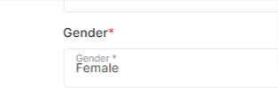

**[Bug:02]**

**Bug Summary:**

[Laptop-Chrome] [Patient Portal] [Sign Up Page] Valid mobile number with hyphen - symbol not working for mobile input field

**Description:**

**Test Environment:**

Browser name with version:Version 120.0.6099.71 (Official Build) (64-bit)

Android Version:

iOS version:iOS 17.1.2

**Test link:**

**Patient portal:**

<https://mean.stagingsdei.com:9157/patient/signup>

**[Steps to Reproduction]**

1.Go to test URL

2.Then on Mobile field select country code and enter the test-data

3.observe the outcome

**[Expected Result]**

Accepts with hyphen - symbol

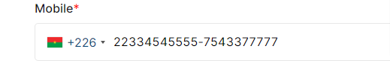

**[Bug:03]**

**Bug Summary:**

[Laptop-Chrome] [Patient Portal] [Sign Up Page] mobile input field accepts over 50 numbers

**Description:**

**Test Environment:**

Browser name with version:Version 120.0.6099.71 (Official Build) (64-bit)

Android Version:

iOS version:iOS 17.1.2

**Test link:**

**Patient portal:**

<https://mean.stagingsdei.com:9157/patient/signup>

**[Steps to Reproduction]**

1.Go to test URL

2.Then on Mobile field select country code and enter the test-data

3.observe the outcome

**[Expected Result]**

Mobile input field accepts under 50 numbers

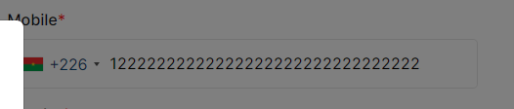

**[Bug:04]**

**Bug Summary:**

[Laptop-Chrome] [Patient Portal] [Sign Up Page]In password field same error message shown for twice time

**Description:**

**Test Environment:**

Browser name with version:Version 120.0.6099.71 (Official Build) (64-bit)

Android Version:

iOS version:iOS 17.1.2

**Test link:**

**Patient portal:**

<https://mean.stagingsdei.com:9157/patient/signup>

**[Steps to Reproduction]**

1.Go to test URL

2.Then click password field and enter test data

3.observe the outcome

**[Expected Result]**

Error message should be show single time

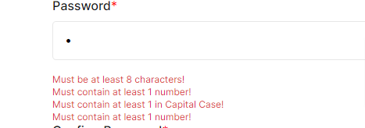

**[Bug:05]**

**Bug Summary:**

[Laptop-Chrome] [Patient Portal] [Sign Up Page]In password error message wrong password appear for missing of one special character

**Description:**

**Test Environment:**

Browser name with version:Version 120.0.6099.71 (Official Build) (64-bit)

Android Version:

iOS version:iOS 17.1.2

**Test link:**

**Patient portal:**

<https://mean.stagingsdei.com:9157/patient/signup>

**[Steps to Reproduction]**

1.Go to test URL

2.Then click password field and enter test data

3.observe the outcome

**[Expected Result]**

Error message should be “must contain at least special character”

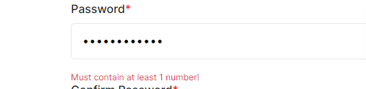

**[Bug:06]**

**Bug Summary:**

[Laptop-Chrome] [Patient Portal] [Sign Up Page] In confirm password wrong confirm password accepts

**Description:**

**Test Environment:**

Browser name with version:Version 120.0.6099.71 (Official Build) (64-bit)

Android Version:

iOS version:iOS 17.1.2

**Test link:**

**Patient portal:**

<https://mean.stagingsdei.com:9157/patient/signup>

**[Steps to Reproduction]**

1.Go to test URL

2.Then click Confirm password field and enter test data

3.observe the outcome

**[Expected Result]**

Confirm Password must be the same data Password data field

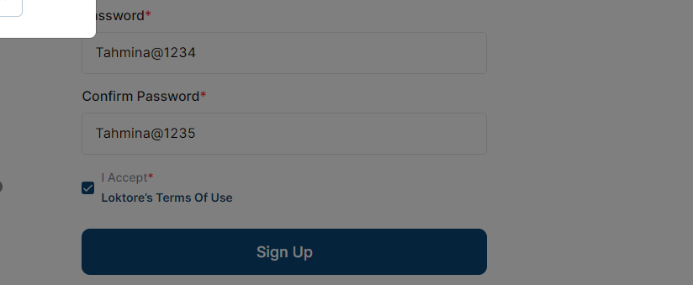

**[Bug:07]**

**Bug Summary:**

[Laptop-Chrome] [Patient Portal] [Sign Up Page] Two factor authentication model must contain a cross or close button

**Description:**

**Test Environment:**

Browser name with version:Version 120.0.6099.71 (Official Build) (64-bit)

Android Version:

iOS version:iOS 17.1.2

**Test link:**

**Patient portal:**

<https://mean.stagingsdei.com:9157/patient/signup>

**[Steps to Reproduction]**

1.Go to test URL

2.Then go to Sign Up Page

3.Then Fill all the field with valid Data

4.Then click on the Sign Button

5.Then show Two factor authentication

3.And observe the outcome

**[Expected Result]**

Two factor authentication should contain a cross button

